Welcome to Oracle Analytics Publisher

Introduction
The Template Builder is an extension to Microsoft Word that simplifies the development of RTF templates. While the Template Builder is not required to create RTF templates, it provides many functions that will increase your productivity.

The Template Builder is tightly integrated with Microsoft Word and enables you to perform the following functions:

- Insert data fields into your RTF templates
- Insert data driven tables and crosstabs
- Insert data driven charts
- Preview and Validate RTF templates with sample XML data
- Browse and update the content of form fields
- Extract boilerplate text into an XLIFF translation file and test translations

This help document assumes a basic working knowledge of Oracle Analytics Publisher. Please refer to Designing and Publishing Pixel-Perfect Reports in Oracle Analytics Server for additional information.

If the template builder is installed correctly, you will see the Publisher ribbon in Microsoft Word:

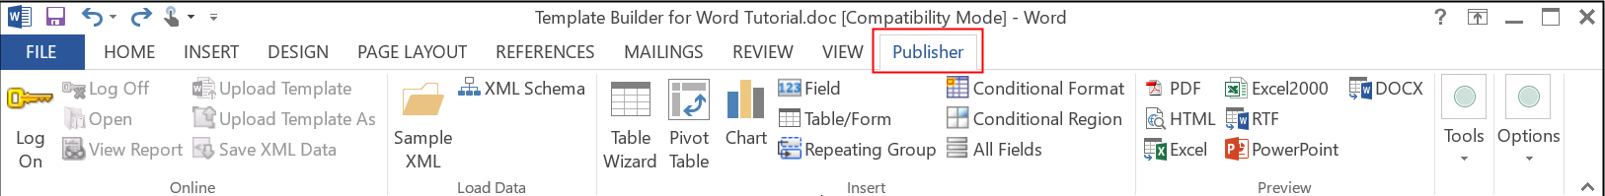

Quick Tutorial
This tutorial describes how you would typically create a simple layout template. You will create a letter that shows the outstanding balance for a customer. This letter contains a table of all unpaid or partially paid invoices.

Open Word File
Often a template starts from an example document in the form of a regular Microsoft Word document.

For this tutorial go to Start > Programs > Oracle Analytics Publisher Desktop > Samples > RTF Templates, open the Balance Letter folder and load the file Balance Letter Start.rtf. This file represents a Word document that has not been marked up for use with Oracle Analytics Publisher.

Load Sample XML Data
From the Publisher > Data menu, select Load XML Data to load a sample XML document that contains the data fields that are returned by the report data model. Loading the sample XML document enables the template builder to present the data fields to you while designing the report.

For this tutorial, go to the samples\RTF templates\Balance Letter folder under your Publisher installation directory and load the Balance.xml file.

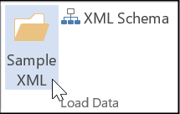

Insert Form Fields
To select single data fields, such as the customer name and address at the header of the letter, position the cursor in the Word document where you want to insert the Address.

- From the Publisher > Insert menu, select Field… to open the dialog window shown below.

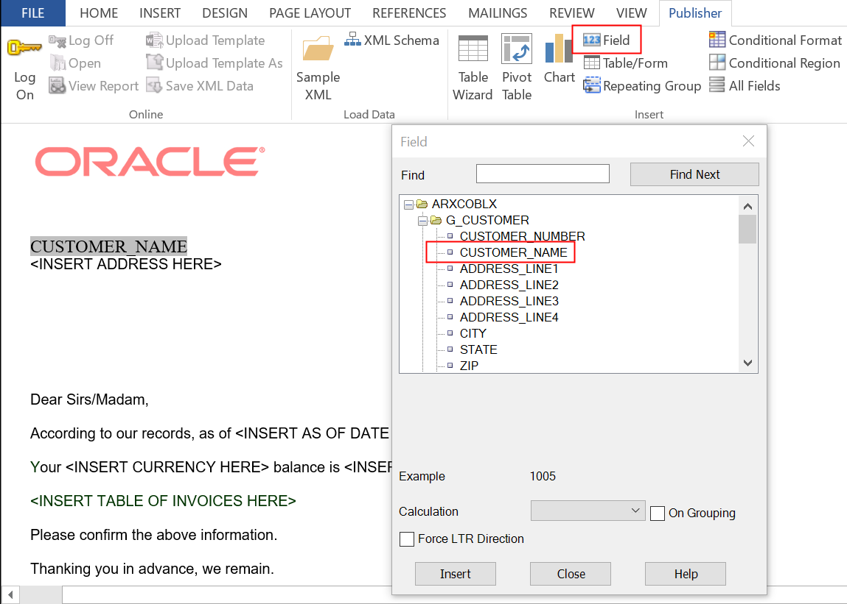

- Select the Customer Name field, and click Insert to insert a form field for the customer name into the document. You may also insert the remaining address fields such as Address Line1 to 4, City, State and Zip. You can also drag the Customer Name field from the dialog and drop it into the Word document.

You can also select the As of Date, Trx Currency Code and the C Inv Open Balance fields, and insert them into the appropriate spaces in the document.

Note: As a beginner, you should use Insert Fields only for data fields that are unique (not repeating) in your document. Refer to the “Insert Table” section for additional information on how to insert repetitive fields

Preview Template
After adding fields to the document, you may want to test your template. Publisher Template Builder allows you to preview your template with your sample XML data. You can preview the output in Adobe Acrobat Reader (PDF), Microsoft Word file (RTF), Microsoft Excel (EXCEL), or a browser (HTML).

From the Publisher > Preview menu, select HTML to preview your template in a browser. From the Publisher > Preview menu, select PDF to preview your document in Adobe Acrobat Reader. You must have Adobe Acrobat Reader version 5.0 or higher installed to preview documents in PDF format. You can download Adobe Acrobat Reader for free.

The preview should show Vision Corporation instead of the field Customer Name.

Insert Table
You can build a table or a repeating section by inserting the elements and then adding additional form fields with processing instructions (for-each). To make this process much simpler, the Template Builder offers an additional function that generates a table for you.

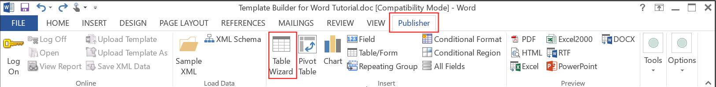

The document should include a table of all invoices that are not paid or only partially paid.

- On the Publisher > Insert menu select Table Wizard… to open the Table/Form Dialog. You get the following dialog:

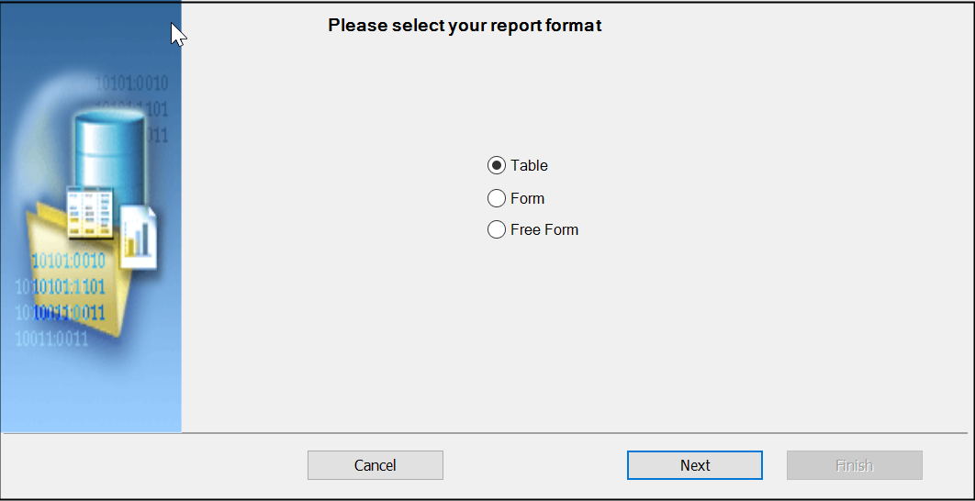

- Select Table and click Next.

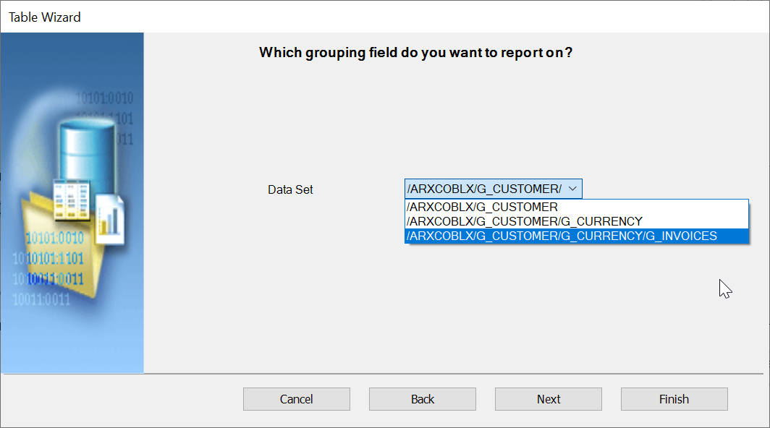

- This dialog allows you to select the dataset you want to display in the table. The XML document may have data from multiple queries group by different criteria. Select the /.../G_INVOICES as the data set for the table and click Next.

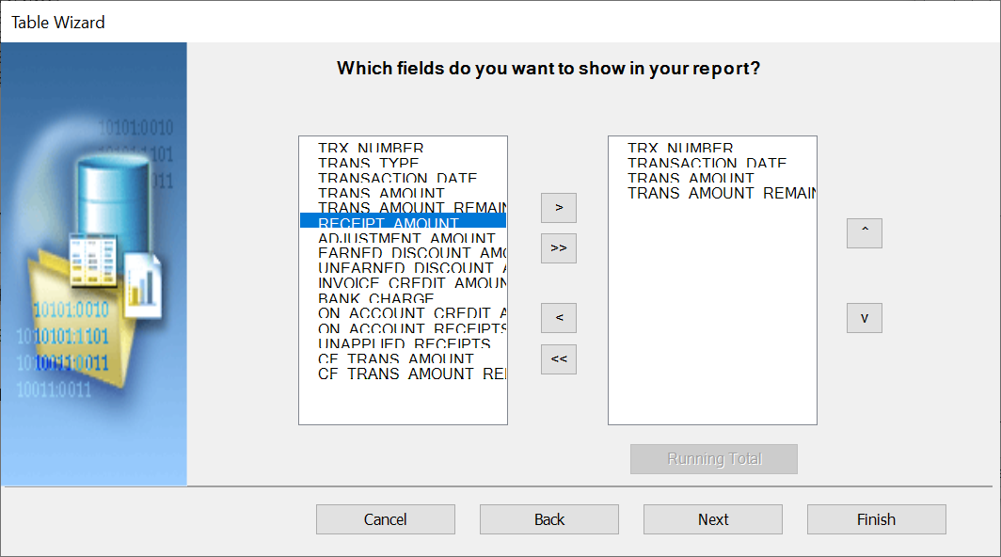

- In this dialog you can select which columns you want to display in your table. We only want to show the fields Trx Number, Transaction Date, Trans Amount, and Trans Amount Remaining. Select the field Trx Number in the left pane and click the > button. Repeat for the remaining fields, until your screen looks as shown above.

- The remaining dialog steps allow you to group and sort the data. This is not required for this tutorial so click the Finish button to create the table. The inserted table should look like this:

Trx Number | Transaction Date | Trans Amount | Trans Amount Remaining
F TRX_NUMBER | TRANSACTION_DATE | TRANS_AMOUNT | TRANS_AMOUNT_REMAINING E

The Template Builder creates two kinds of form fields:

- Form fields representing data elements
- Form fields with processing instructions for repeating table rows or document sections

Form fields representing data elements are replaced with the data when the template is processed. The F and E form fields indicate a repeating section. The section of the document encapsulated by these two form fields is repeated, if the associated data element G_INVOICE is found repetitively in the data. Please refer to the Designing and Publishing Pixel-Perfect Reports in Oracle Analytics Server for additional information on form fields.

You can now format these elements in Microsoft Word and add additional text. You can also move fields around as long as you keep them in the surrounding F and E processing instruction. If you remove one of these processing instructions your template may not work anymore with Publisher.

You now can preview the template again to review your current template. You probably would like to change the alignment of the table columns or change the data type and format for the amounts. For example, select the TRANS_AMOUNT field, right-click and select Publisher > Properties to see the Properties dialog.

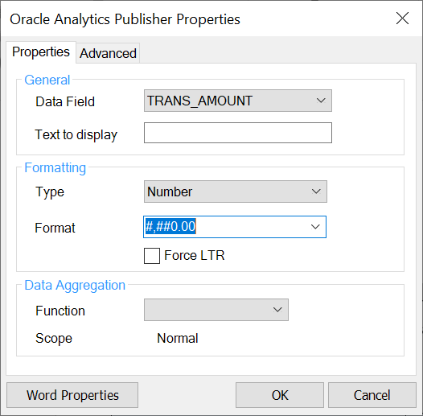

You may select the Number in the Type field, #,##0.00 for Number format and enter 1000 as the Default Number to achieve a more desirable format for currencies in US Dollar. We recommend not to use currency signs such as $ in the format string, since it may lead to difficulties in supporting multiple languages with a single template.

Formatting options defined in this dialog box are understood by Oracle Analytics Publisher and used to format your fields. You can modify the template to get an idea which Word functions are supported by Publisher.

Creating Charts
The data used for creating the open balance letter is not well suited to create a chart. Close the previous Word document and open a new Word document. Then load the RetailSales.xml file in the samples\RTF templates\Sales Report folder by selecting Load XML Data from the Data menu.

This data contains retail sales data for different industries. We will create a chart that shows the sales per industry. Publisher does not support native Microsoft Word Charts. You need to create charts using the Template Builder.

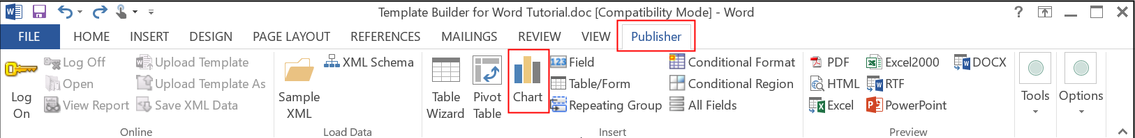

- On the Publisher > Insert menu select Chart… to open the Chart Dialog.

- On the left tree view pane drag Industry to the Labels field, to see the data accumulated by industry. Then drag Sales to the Values field. Select a Pie Chart as the Type and click the Preview button to see how the chart will look with the sample data. Then click OK to insert the chart into the RTF template.

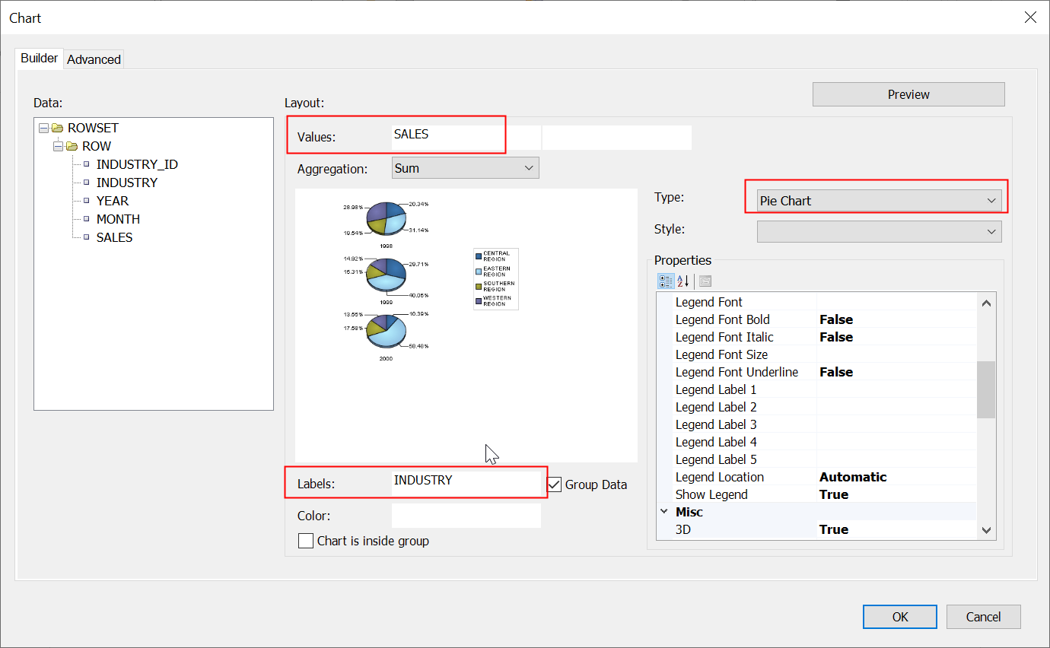

The Template Builder will insert the placeholder image shown below for the chart. To change the size of the chart, you can just resize the placeholder image.

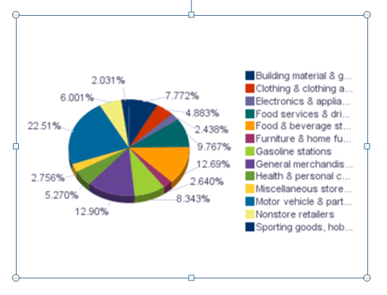

- From the Preview menu select HTML to preview your template in a browser. From the Preview menu select PDF to preview the output in Acrobat Reader.

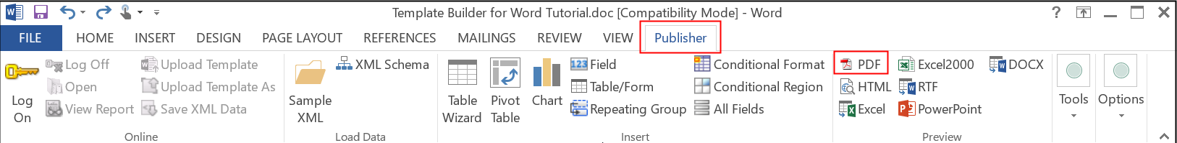

The preview will show the correct chart for the preview data:

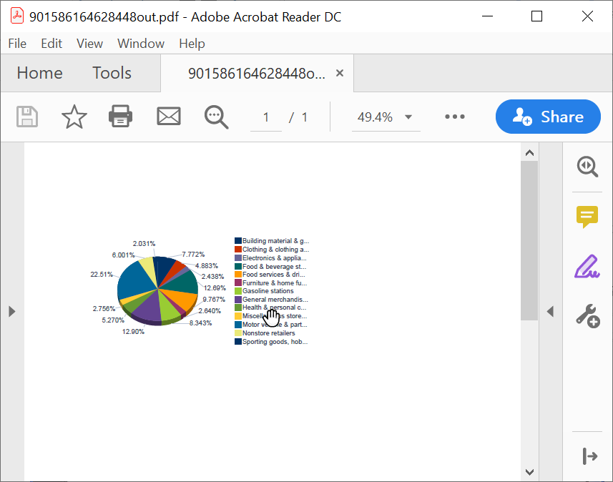

Please refer to Designing and Publishing Pixel-Perfect Reports in Oracle Analytics Server for additional information regarding charts.

Next Steps
This concludes the quick tutorial. Try to create your own template now. Refer to the help file for additional information. See the “Creating an RTF Template” topic in the Designing and Publishing Pixel-Perfect Reports in Oracle Analytics Server guide packaged with the Template Builder. The Guide is accessible from the Start menu under Oracle Analytics Publisher Desktop.

